Image | 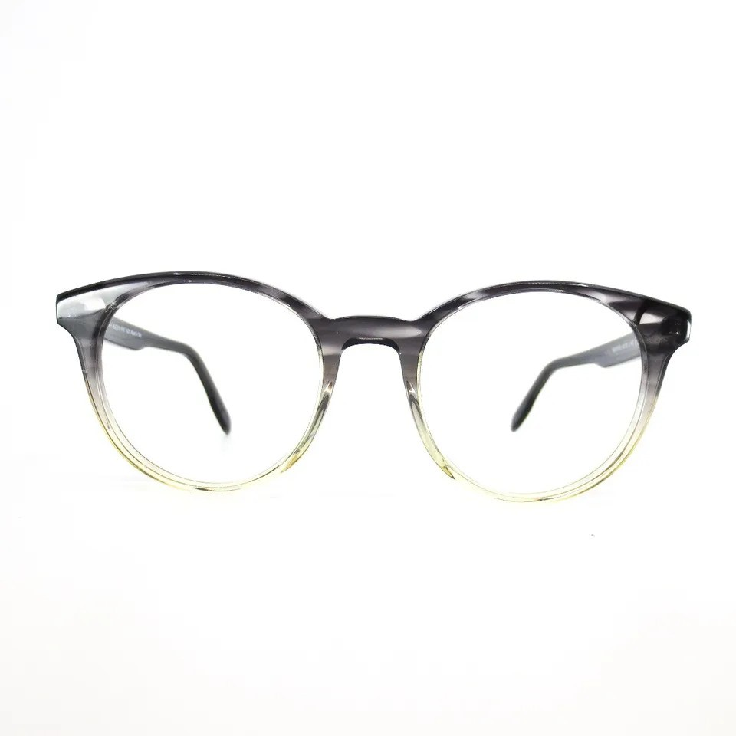
Brand | TIFFANY & CO.
Model Name | MJ 02118
Price | RS 2000
PRODUCT DETAILS

